Chapter 13, Problem 35.

Find currents I₁, I₂, and I₃ in the circuit of Fig. 13.103.

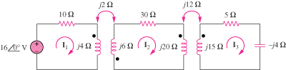

Figure 13.103
For Prob. 13.35.

